Machine Learning

1. Supervised
   1. Regression
      1. Linear Models
         1. Basic
         2. Regularized
            1. Lasso (L1)
            2. Ridge (L2)
            3. Elastic Net
   2. Classification
      1. KNN ("K Nearest Neighbors)
      2. Logistic Regression
         1. Basic (Binary)
         2. Multinomial
2. Unsupervised
   1. Clustering
      1. Density Models (DB Scans)
      2. Centroid Models (K Means)
      3. Connectivity Models (Hierarchical)
         1. Decision Trees
         2. Random Forests
      4. Distribution Models

Useful Pandas DataFrame methods

.info()

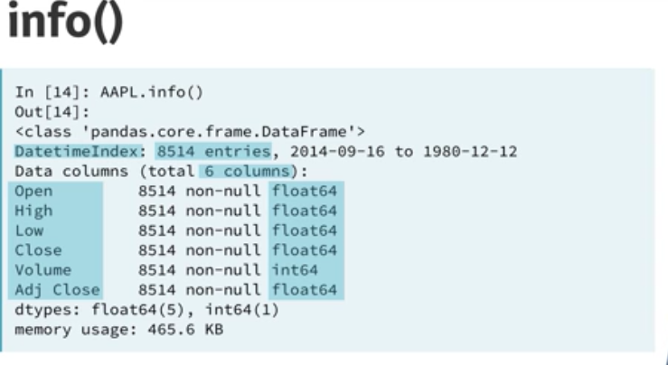

Broadcasting is assigning values to cells in DF?